Install Kubernetes

Commands used -

* curl -s <https://packages.cloud.google.com/apt/doc/apt-key.gpg>| apt-key add - echo "deb <http://apt.kubernetes.io/>kubernetes-xenial main"
* >/etc/apt/sources.list.d/kubernetes.list apt-get update
* apt-get install -y kubelet kubeadm kubectl

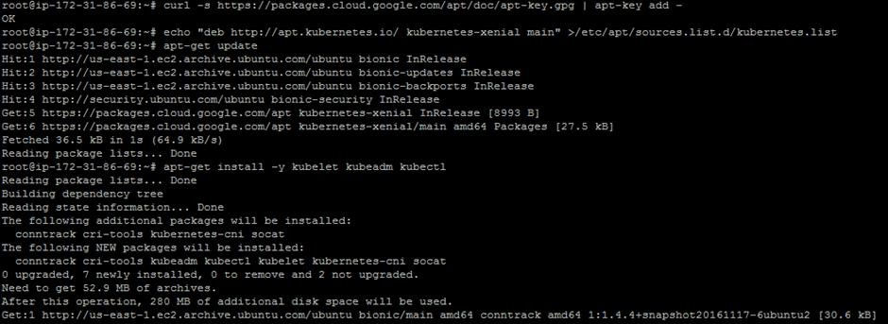

* kubeadm init

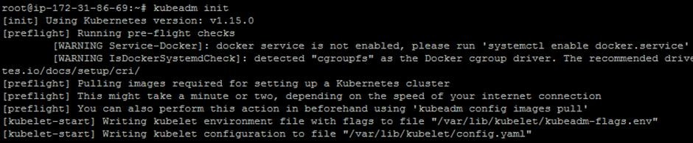

* mkdir -p $HOME/.kube
* sudo cp -i /etc/kubernetes/admin.conf $HOME/.kube/config sudo chown $(id -u):$(id -g) $HOME/.kube/config

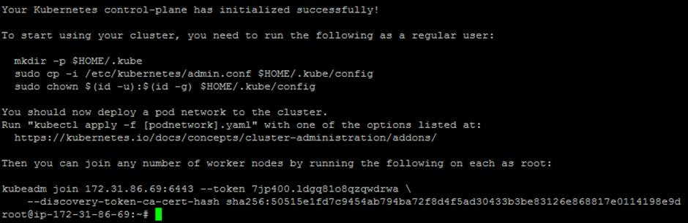

* export kubever=$(kubectl version | base64 | tr -d '\n')
* kubectl apply -f "[https://cloud.weave.works/k8s/net?k8s-version=$kubever](https://cloud.weave.works/k8s/net?k8s-version=%24kubever)"

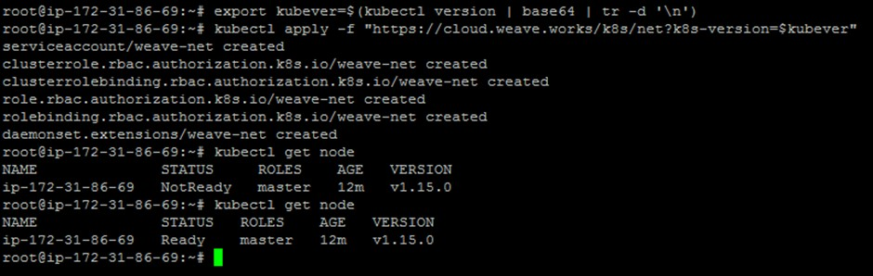

* kubectl get node
* kubectl get pods --all-namespaces

